Dan Sabers Boot Camp Dynasty League Official Rule Book

  - This is the official rule book for the dynasty league; it will be viewed only by everyone but Avery. Rule changes will all be discussed and voted on the Stalkfleet’s Body Pillow text only. Any other votes are invalid.

Contents
1.0 Salary Cap Model 3
1.1 Formula 3
1.2 Taxi and IR 3
1.3 Trade Limits 3
1.4 Consequences 4
2.0 Point Scoring 4
2.1 Passing 4
2.2 Rushing 4
2.3 Receiving 4
2.4 Kicking 5
2.5 Other 5
3.0 Free Agency 5
4.0 Playoffs 5
Five team playoffs: 5
Consolation Ladder 6

1.0 Salary Cap Model

1.1 Formula
Each Teams Salary Cap is $1,000. Each player is assigned values based on the formula listed below
$$Cost=\frac{201-\left(Player Ranking\right)}{2}$$

The player ranking is updated at the start of the league new year based on the parameters shown. The year is the most recently completed season.
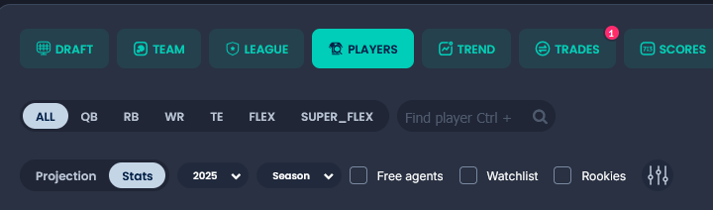
If found to be over the cap, you have up to the next Thursday night game to fix your roster. If compliance is not followed, then your roster will be frozen and the next available 2nd round draft pick will be awarded to the last place member in the league at that given time.

1.2 Taxi and IR
Taxi squad players do not count towards the salary cap, but Injured reserve players do.

1.3 Trade Limits
To trade for a player, you must have available cap space on your roster prior to the trade being completed. For instance, if the player you are trading for is $100.00, then you must have at least $100.00 available. That $100.00 can either be previously existing roster space or be freed up with players you give in exchange during the trade.

1.4 Consequences
After league new year:
- Teams will have approximately 1 month to update roster with new player values Failure will result in roster being frozen and must contact Avery to force drop players. No trades allowed until under cap
- During off season, cap sheet will be checked every Sunday unless requested earlier. From then, you will have two weeks to fix cap issues before being frozen and forced to drop players.
- If found to be over the cap during the season, you have up to the next Thursday night game to fix your roster. If compliance is not followed, then your roster will be frozen and the next available 2nd round draft pick will be awarded to the last place member in the league at that given time.

2.0 Point Scoring
Also viewable on sleeper league settings.

2.1 Passing
Passing TD | 4
Passing 1st Down | 0.1
2-Pt | 2
Pass Intercepted | -2
Pick 6 Thrown | -2
40+ Yard Completion | 1

2.2 Rushing
Rushing Yards | 1 pt / 10 yards
Rushing TD | 6
Rushing 1st Down | 0.5
2 Pt Conversion | 2
40+ Yard Bonus | 1

2.3 Receiving
Reception | 1
Receiving Yards | 1 / 10 yards
Receiving TD | 6
Receiving 1st down | 0.5
2 pt Conversion | 2
30-39 yard receiving bonus | 0.5
40+ yard reception bonus | 1
Reception Bonus TE | 0.5

2.4 Kicking
Field Goal Made | 3
Field Goal Made 40-49 yards | 4
Field Goal Made 50+ | 5
PAT Made | 1
Field Goal Missed | -1
PAT Missed | -1

2.5 Other
Fumble Lost | -2
100-199 Rushing | 1
200+ Rushing | 2
100-199 receiving | 1
200+ receiving | 2
300-399 Passing | 1
400+ Passing | 2
100-199 combined rush + receive | 1
200+ rush combined | 2

3.0 Free Agency
Free agent budget in sleeper app to be $100. This budget is tradable like draft picks.

4.0 Playoffs

4.1 Five team playoffs:
- Top 4 teams, 5 seed is best remaining based on total points scored
- 4 plays 5 week 14
- Seeds 1-3 get week 14 bye
- Week 15 semi finals
- Finals Weeks 16-17

4.2 Consolation Ladder
- Bottom 5 teams
- 9 plays 10 week 14
- 6-8 get week 14 bye
- Week 15 semi finals
- Finals week 16-17

4.3 Draft Picks
- regular season 10 is first overall
- consolation winer is 2
- picks 3-9 are regular season standings
- 10th pick is champion\

